**Red Team: Summary of Operations**

**Table of Contents**

* Exposed Services
* Critical Vulnerabilities
* Exploitation

**Exposed Services**

**Target 1**

Nmap scan results for each machine reveal the below services and OS details:

$ nmap -sC -sV –reason -p 22,80,111,139,445 192.168.1.110

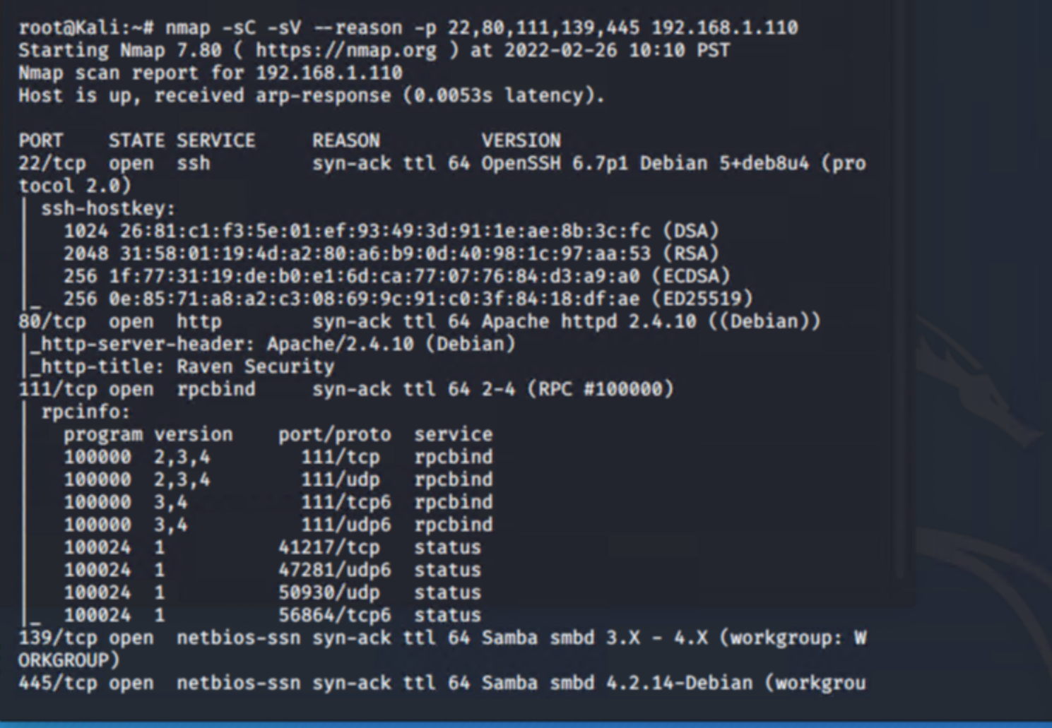

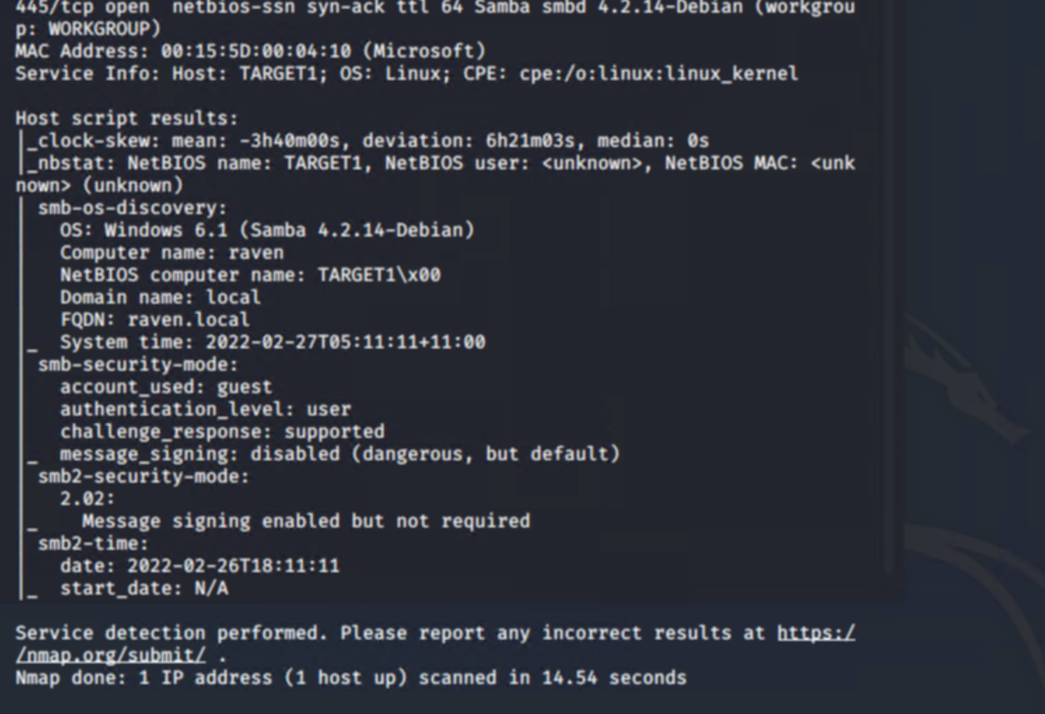

This scan identifies the services below as potential points of entry:

Target 1: List of Exposed Services

* Port 22/tcp open ssh (service) OpenSSH 6.7p1 Debian 5+deb8u4
* Port 80/tcp open http (service) Apache httpd 2.4.10 ((Debian))
* Port 111/tcp open rpcbind (service) 2-4 (RPC #100000)
* Port 139/tcp open netbios-ssn (services) 64 Samba smbd 3.X - 4.X
* Port 445/tcp open netbios-ssn (services) Samba smbd 3.X - 4.X - Debian

The following vulnerabilities were identified on each target:

Target 1 List of Critical Vulnerabilities

* [CVE-2021-28041 open SSH](https://nvd.nist.gov/vuln/detail/CVE-2021-28041)
* [CVE-2017-15710 Apache https 2.4.10](https://nvd.nist.gov/vuln/detail/CVE-2017-15710)
* [CVE-2017-8779 exploit on open rpcbind port could lead to remote DoS](https://nvd.nist.gov/vuln/detail/CVE-2017-8779)
* [CVE-2017-7494 Samba NetBIOS](https://nvd.nist.gov/vuln/detail/CVE-2017-7494)

*Critical Vulnerabilities:*

The following vulnerabilities were identified on **Target 1**:

* Nmap was used to discover open ports.

Open ports enabled to perform the attack successfully.

* Weak User Password
  + A user had a weak password which was easy to guess.
    - So SSHing into the web server was easy.
* Unsalted User Password Hash (WordPress database)
  + Wpscan was utilized to gain username information.
    - The username information was used by the attackers to help gain access to the web server.
* MySQL Database Access
  + The attackers were able to discover a file containing login information for the MySQL database.
    - Able to use the login information to gain access to the MySQL database.
* MySQL Data Exfiltration
  + By browsing through the various tables in the MySQL database the attackers were able to discover password hashes of all the users.
    - The attackers were able to exfiltrate the password hashes and crack them with John the Ripper.
* Misconfiguration of User Privileges/Privilege Escalation
  + The attackers noticed that Steven had sudo privileges for python.
    - Able to utilize Steven’s python privileges in order to escalate to root.

**Exploitation**

* Target 1

The Red Team was able to penetrate **Target 1** and retrieve the following confidential data:

* Enumerated WordPress site Users with WPScan to obtain username michael, used SSH to get user shell.
* Command used: wpscan --url <http://192.168.1.110/wordpress> -eu

root@Kali:~# wpscan --url http://192.168.1.110/wordpress -eu

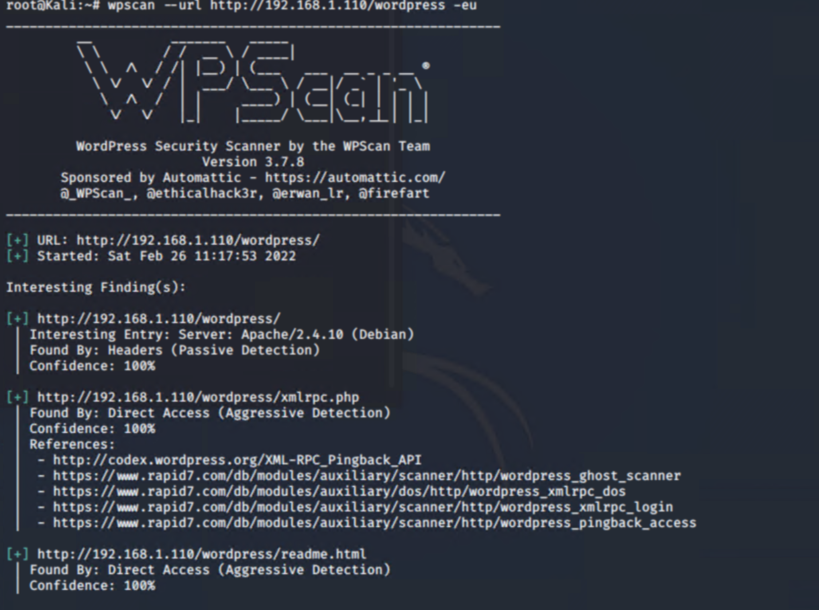

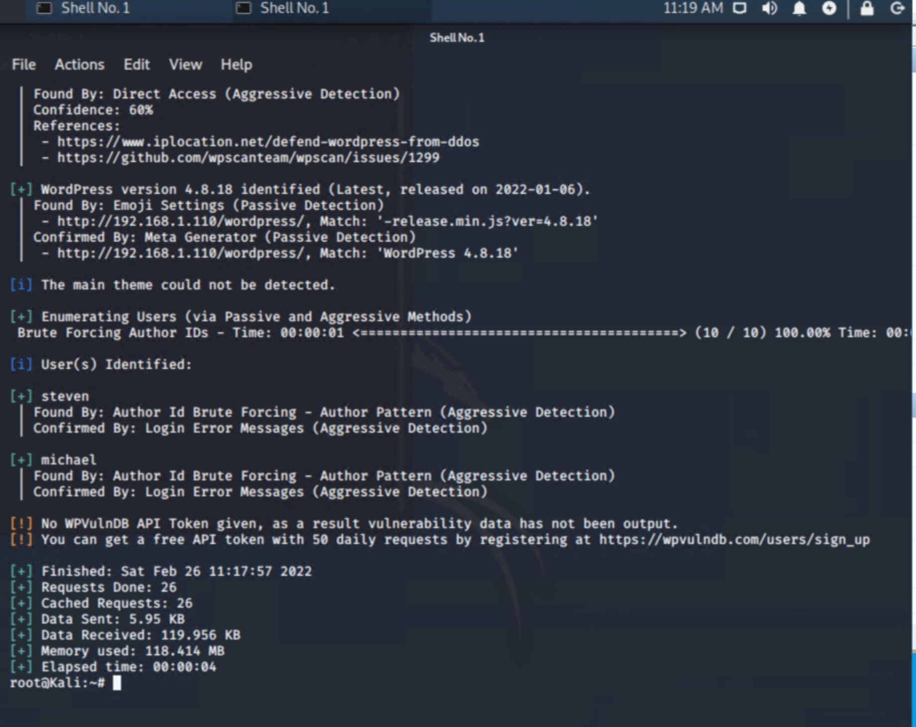

* + flag1.txt:

command used :

grep -RE flag html

* 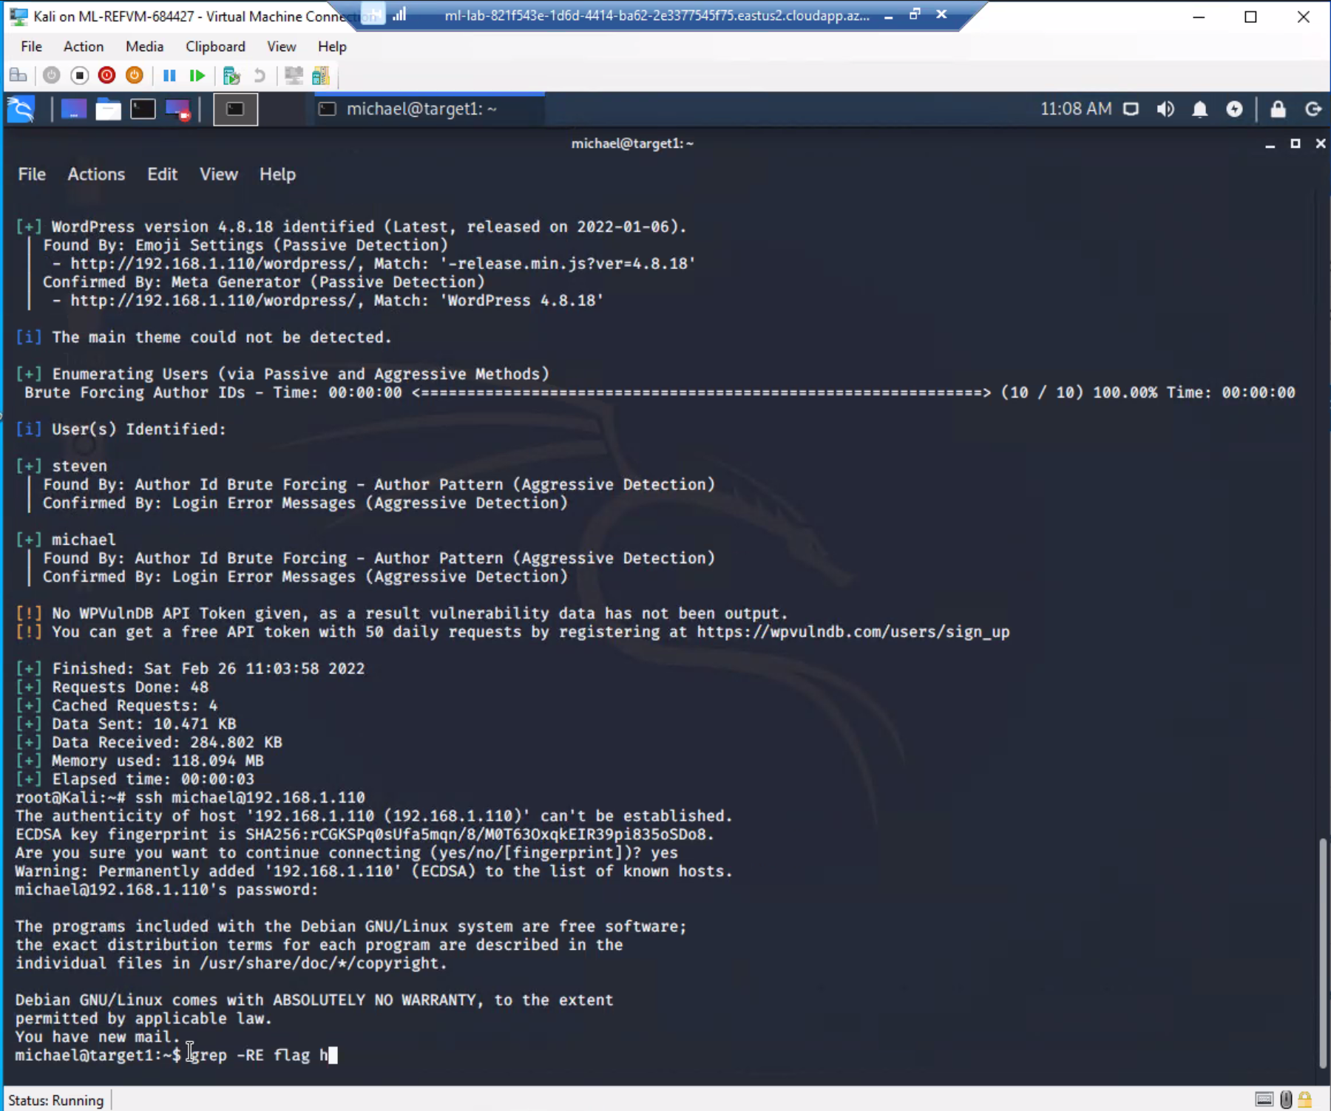
* 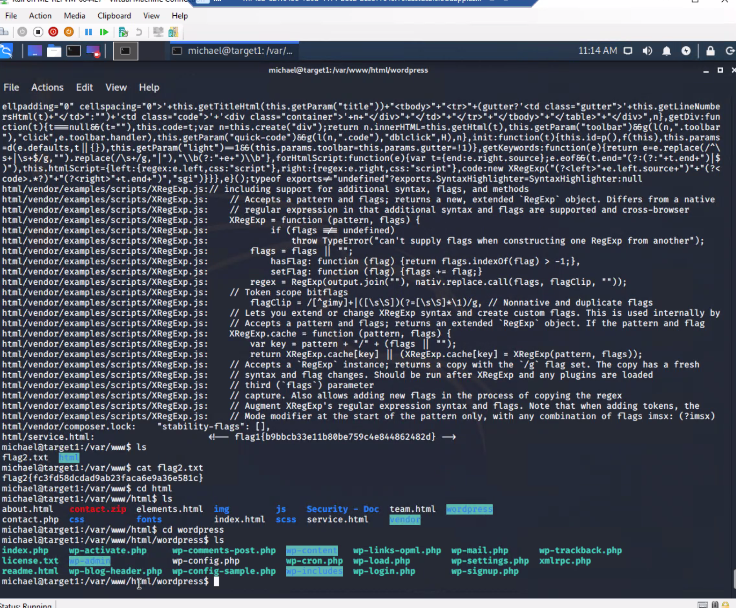
  + 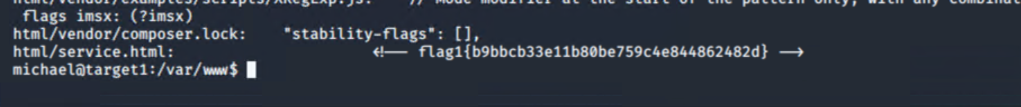
    - **Exploit Used**
* ssh into **Michael’s** account and look in the/var/www files
* **Command:** ssh [michael@192.168.1.110](mailto:michael@192.168.1.110)

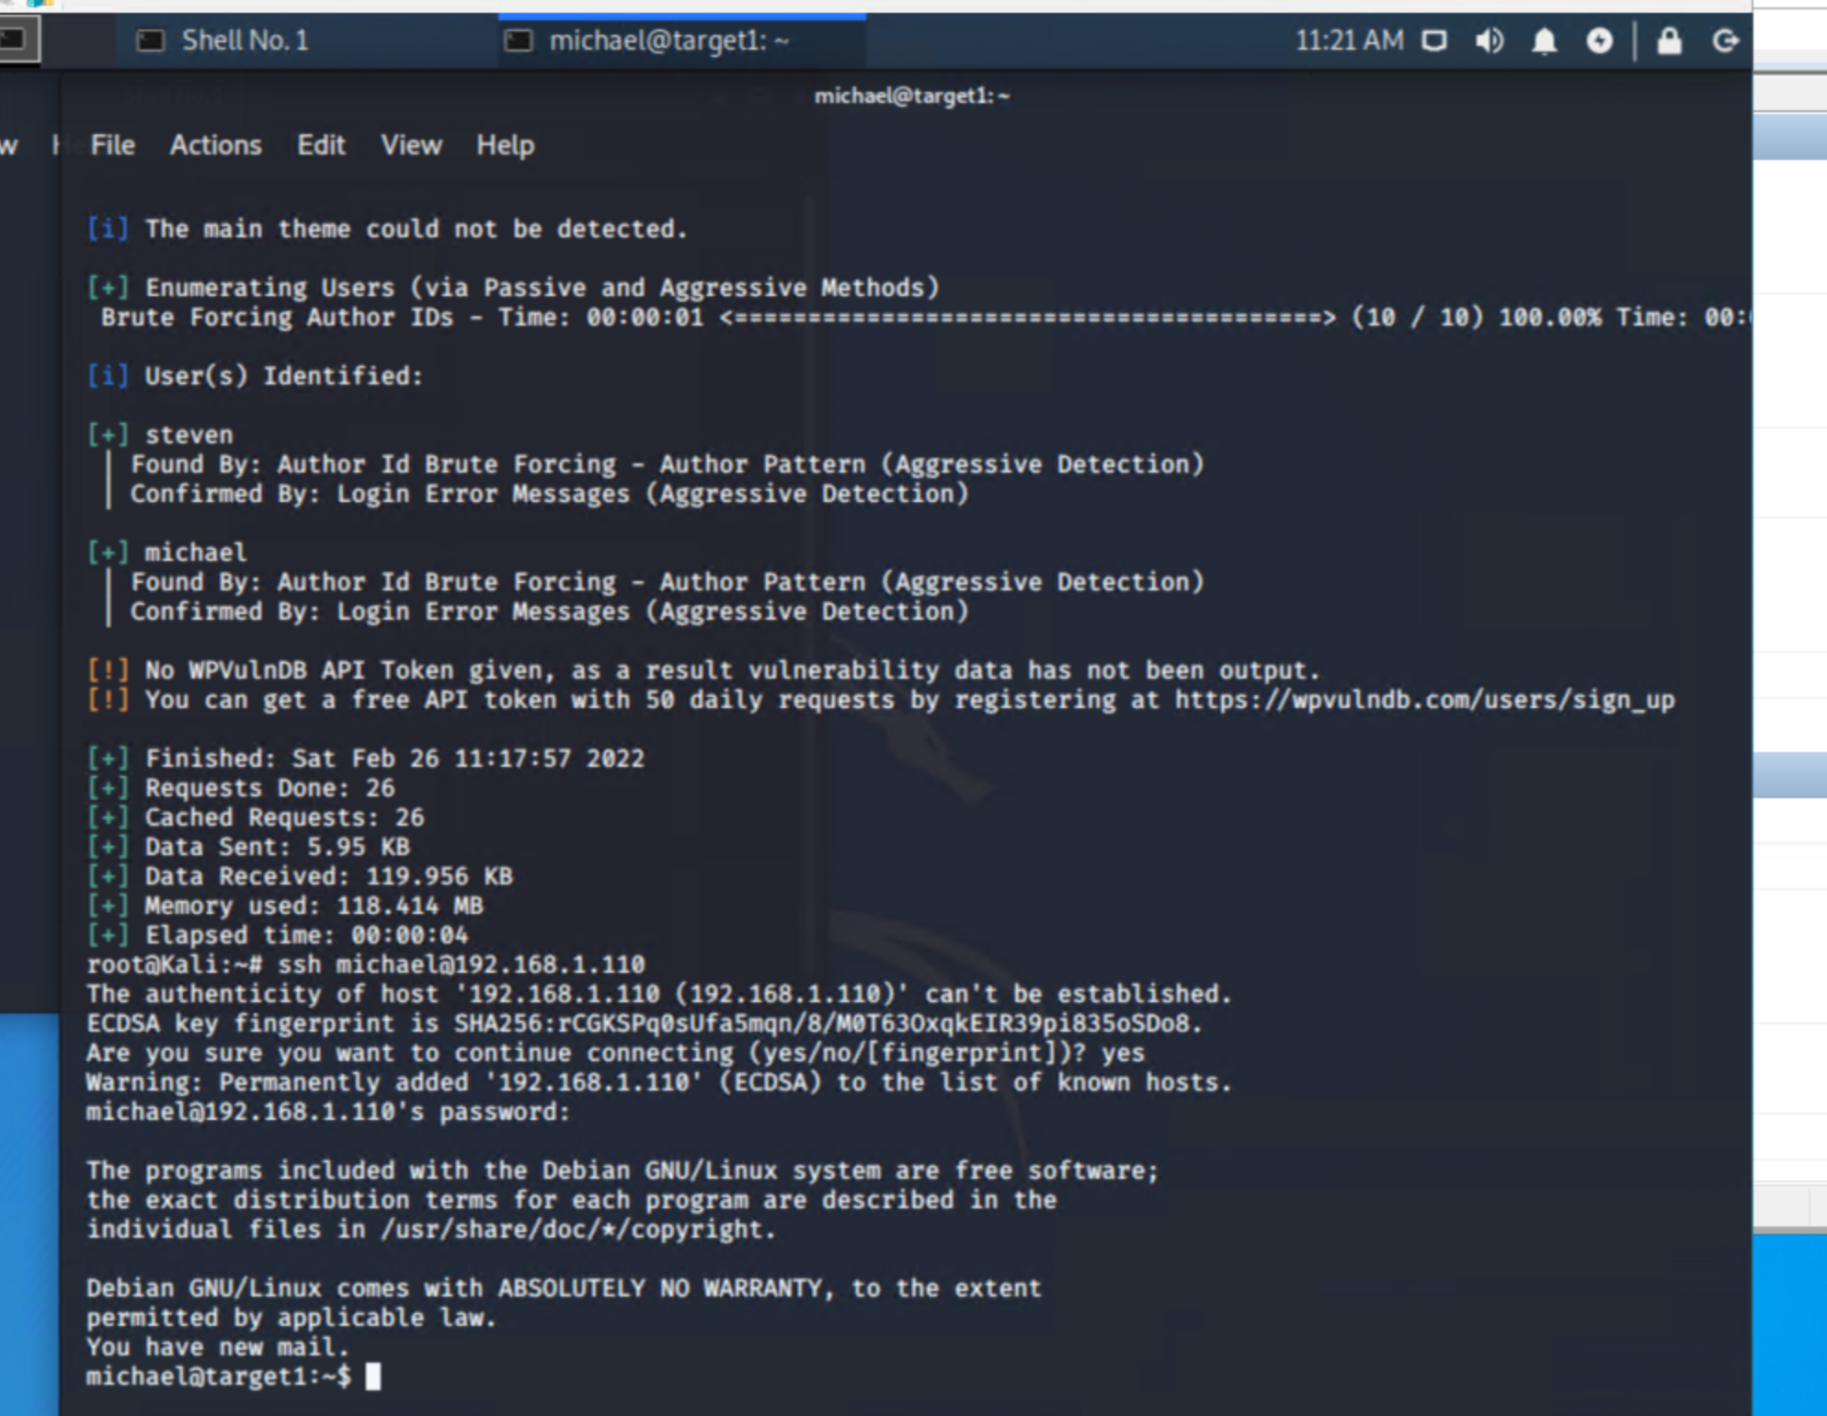

* + flag2.txt: 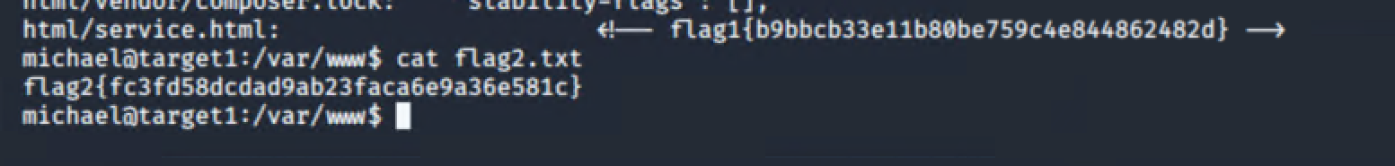
    - **Exploit Used**

Look in the /var/www files

Command cat flag2.txt to reveal the password hash

